**Kalispell Public Schools**

Kalispell Public Schools is a high performing district which requires collaboration, innovation, and passion for quality education. Surrounded by Glacier National Park, Flathead Lake, and Whitefish Mountain Resort, the Flathead Valley is the perfect location for a committed educational leader, who enjoys a strong public school system within a vibrant community.

**Our Schools**

Kalispell Public Schools serves approximately 6300 students through its ten schools.

⬧ Edgerton Elementary ⬧ Kalispell Middle School

⬧ Elrod Elementary ⬧ Flathead High School

⬧ Hedges Elementary ⬧ Glacier High School

⬧ Peterson Elementary ⬧ Linderman Education Center

⬧ Rankin Elementary⬧ H.E. Robinson Agricultural

⬧ Russell Elementary Education Center

**Our Commitments**

Kalispell Public Schools’ core purpose is to provide diverse educational opportunities and challenges that engage students, meet their unique needs, and prepare them for the future. We believe that

⬧ the best decisions are made in the interest of students.

⬧ every student can learn and succeed.

⬧ high expectations produce high achievement.

⬧ excellent schools have a positive impact on communities.

⬧ effective and efficient public education is a critical economic investment.

* parent engagement plays a critical role in student success.

As a member of the Central Administrative Team, the Director of Business Service plays a vital role in operational and strategic initiatives, forecasting and ensuring the long-term financial sustainability of the District while keeping student learning as a primary focus.

Kalispell Public Schools has a $42 million-dollar general fund and oversees an annual budget including state, federal and local funding that exceeds $105 million. This position directs the work of the business office which include five additional staff members and supervises the Food Service Manager.

***KPS Mission***

***To provide diverse educational opportunities for all by engaging and challenging students, meeting their unique needs, and preparing them to be career and/or college ready resulting in responsible citizens of our communities, state, nation, and world.***

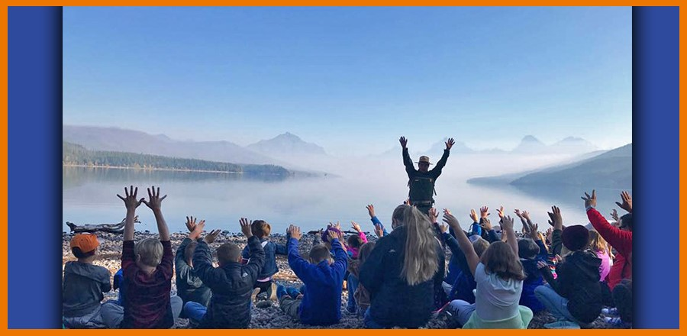

**SD5**

**SD5**

**SD5**

**LPW**

**POSITION ANNOUNCEMENT**

**Director of Business Service**

**KALISPELL PUBLIC SCHOOLS**





**Position Characteristics**

**Job Responsibilities Include**

* Responsible for the operation, oversight, and financial integrity of all financial related aspects of the school district operationsincludinggeneral ledger, accounts receivable, accounts payable, payroll, food services, capital assets, revenue, tuition, and student extracurricular accounts.
* Prepares and manages various financial reports and processes including annual budgets, capital planning, trustees reports, Comprehensive Annual Financial Report, OPI required reports, district procurement, contracts, bidding, and risk and insurance programs.
* Applies governmental accounting practices, generally accepted accounting principles, IRS, state and other regulatory requirements, inventory control, and district policies.
* Assesses, monitors, and improves district operations and programs in relation to financial impacts, projections, alternatives, and policy.
* Acts as liaison for federal and state grant financial administration with district auditor, with County Clerk and Recorder and Treasurer, and with other state and local officials.
* Investigates and corrects for procedural errors or violations of internal control, state or federal regulations, or laws related to finance.
* Serves as the District Clerk under the direction of the Board of Trustees.

**Qualifications**

* Requires Bachelor’s degree in related field.
* Preferred advanced technical and professional skills in all areas of responsibilities and duties including Montana finance law and school finance law.
* Preferred experience in public school administration.
* Preferred experience in efinance accounting software.
* Preferred experience as a Certified Public Accountant.

## ***Kalispell Public Schools... "A Great Place to Learn, Live and Work."***

