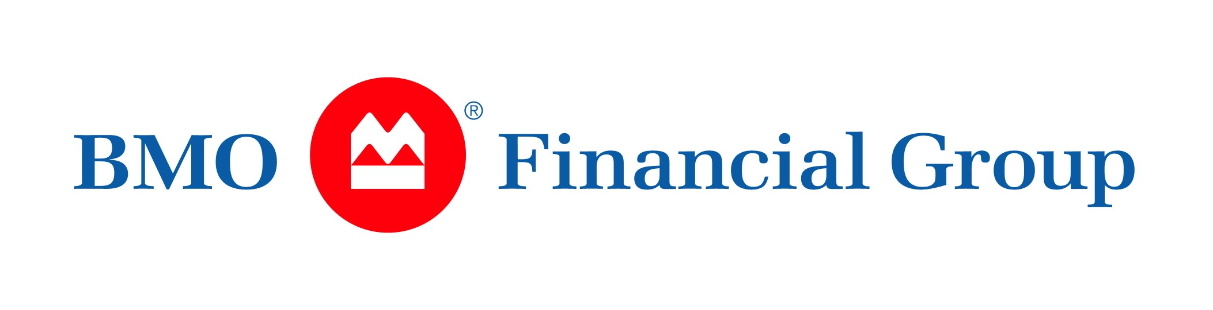
BMO Treasury & Payment Solutions

Purchasing Card Handbook


A step-by-step guide to everything you need to know about your purchasing card program.
TABLE OF CONTENTS

Section 1 – Starting a p-Card Program [complete]

Forms you need to send in to start your program
- Forms Checklist
- Application, Member Agreement and Resolution

Section 2 – Implementation

- Implementation Forms
- Policy and Procedures
- Types of cards

Section 3 – What to do when you receive your cards

- Distribute Cards to Your Cardholders
- Activate Cards
- Attend Spend Dynamics Training via Webcast
- Spend Dynamics Username and Password

Section 4 – Administering the p-Card Program

- Client Services
- Requesting New Cards
- Payment
- Adding a New Program Administrator

Section 5 – Other information to consider

- Requesting an Overall Corporate Credit Increase
- Submitting Yearly Audited Financial Statements
- Website information to reference
Section 1 – Starting a p-Card Program [complete]

The checklist below contains everything you will need to submit in order to get your program started. After sending all the information, an Implementation Manger from BMO Treasury & Payment Solutions will give you a call to verify the information, and go over any questions you may have.

Checklist of item you need to send in to start your program:

    - Application
    - Signed Member Agreement
    - Signed Original of the Board of Education Approving Resolution
    - The last 3-years of Audited Financial Statements

Send to:
p-Card Application
Illinois ASBO
Northern Illinois University, IA-103
108 Carroll Ave.
DeKalb, IL 60115-2829

Section 2 – Implementation

Checklist:

    - Organization Set-up Form (one for each Program Administrator)
    - Authorization Controls Set-up Table (one for program)
    - New Accounts Request Template and instructions for required fields, for initial card order
    - ACH Debit Form (required for payment by ACH)

The above listed forms are attached below:

ONCE COMPLETED, EMAIL OR FAX TO YOUR IMPLEMENTATION MANAGER.

Other Considerations

It is suggested that a purchasing card policies and procedures manual be created for your cardholders.

The sample below is meant to give you an idea of what a policies and procedures manual may include. There are no samples of the documents referenced in the sample as the forms are just an idea of something you may want to create for your organization. The documents would only be internal and would be used between you as the program administrator and your cardholders.

- 1st line will be cardholder name or department name.
- 2nd line will be Organization Name, Tax Exempt #, or combination of both.
Types of Cards

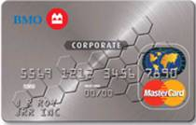

Plastic in Name of Person
Putting the cardholder’s name on the card is recommended.
Advantages: Security (you know who is using the card) also there is no additional cost for cards (you can have as many as you want).

Plastic in Name of Department
Department name replaces cardholder name as responsible party (example: Independent School District #58). These cards can be handed out to different individuals for use. It can also reside with a specified high-volume vendor, or can be utilized in web-based or telephone orders.

Ghost Card (cardless account)
Ghost cards are cardless accounts. You will receive a letter with the card number, the expiration date and three digit security code on the back. These cards can be utilized in web-based or telephone orders.

Section 3 – What to do when you receive your cards

Cards are delivered approximately 10-12 business days after you have returned the Implementation set-up forms to your Implementation Manager. When you receive your cards you will need to:

- Distribute Cards to Your Cardholders
- Activate Cards
- Attend Spend Dynamics Training via Webcast
- Spend Dynamics Username and Password (not automatic)

Distribute Cards to Your Cardholders

Important! Ensure a signed acknowledgement form is kept on record indicating the cardholder understands the rules set for using the card.

Here is a sample cardholder acknowledgement form:

Activating Cards

The best way to activate your cards is to call the number provided on the back of card to complete the activation.

Spend Dynamics Access and Training

You will receive emails with your Spend Dynamics username and temporary password within 10-12 business days after your Implementation Manager has confirmed all forms have been completed, and your program is ready to be set-up. You will be required to select a new password when you login for the 1st time. Your role as an Administrator allows you to create access and passwords for the rest of your cardholders, managers, and administrators.

While the tool is user-friendly and intuitive, we’ve developed web-based training, and a Quick Reference Guide to help you gain the most value from it. The training modules for both card Program Administrators and cardholders can be accessed via the link below, as well as in the Spend Dynamics help menu. We strongly encourage you to attend the training and use the quick reference guides prior to using the system.

BMO Spend Dymamics Training Catalogue

Section 4 – Administering the p-Card Program moving forward

Our client services department is available to assist you with any questions or problems related to your Purchasing Cards or BMO Spend Dynamics:

Client Services: Monday to Friday 8:00am - 8:00pm EST Local time for CPA requests and regular office support (Except Pacific time zone 08:00 - 17:00 Local).

Contact Center (after hours): 24/7/365 IVR for general inquiries. Lost or Stolen cards can be reported to a Security Officer on Sundays (number located on the back of the cards)

The following can be accomplished by calling client services:
- Canceling cards
- Changes to hierarchy
- Changes to authorization controls or adding special controls
- Changing card limits
- Billing information
- Billing questions
- New account requests
- Account name changes or address changes
- Spend Dynamics questions
- Card decline information

NOTE: The above can also be completed online via Spend Dynamics. This is beneficial for after hours inquiries/ service requests.

Requesting New Cards

New cards can be requested via Spend Dynamics (status of request can be tracked online) or by filling out the Cardholder Spreadsheet (listed in Section 2) and emailing your request to iasbo.requests@bmo.com. Any follow-up can be done by contacting client services directly at (800) 844-6445.

Payment Information

ACH Payment: funds for payment will be automatically deducted from your account at the end of your grace days(on the due date). (Calendar days, not business days)

Example: If your billing date is the 5th (statement cut-off) and you have 21 grace days, your payment will be debited on the 26th of every month (the due date).

Pay By check: if you are paying by check here is some information. Kindly ignore the attached document if the ACH option is chosen.

Adding or Deleting a Program Administrator

Important! Each time you add or delete an administrator, it is very important to notify BMO/ Harris. You can email Client Services directly, to advise us of any new Administrators, and/or deletion of an existing Administrator.

For new Administrator(s); The Bank requires the signature of the authorized individual before taking any direction from that person. To add a new program administrator, fill out the form below and fax it to (888) 224-5393, or via email at iasbo.requests@bmo.com. Any follow-up can be done by contacting client services directly at (800) 844-6445.

Section 5 – Other information to consider

Requesting an Overall Corporate Credit Increase

Important! Since this is different from simply raising a card limit, a little more effort and analysis must be undertaken by BMO/ Harris financial group. If you would like to discuss increasing your corporate credit limit, please contact your account manager:

Tonya Bragg
Office: 312-461-6848
Fax: 312-293-4718
tonya.bragg@bmo.com

Submitting Yearly Audited Financial Statements
Every year your purchasing card credit will be reviewed. Therefore, you will need to provide your annual audited financial statements to the bank within thirty (30) days of completion. The statements should be sent by U.S. mail or courier to:

111 West Monroe Street
Floor 5 Center
Chicago, IL 60603
Attention: Institutional Group / Jordan Ruiz
pcard.reviews@bmo.com

Website Information to Reference:

p-Card specific website: http://www.illinois-pcard.com/

This website contains everything p-Card specific. It has a listing of other districts currently on the program, forms and *new* information.

