|  |  |
| --- | --- |
| MASBO Hiring Guide supplemental documents  Word format updated Dec 9, 2024 | Abstract  The document provides comprehensive job descriptions, qualifications, and evaluation criteria for various administrative positions within a school district, including Business Official/District Clerk, Business Manager, and School District Clerk. |

# Appendix A1- Job Descriptions

#### Sample one

Job Title: BUSINESS OFFICIAL/DISTRICT CLERK

Classification: Administrator

Reports To: Superintendent of Schools/Board of Trustees FLSA Status: Exempt/Classified

SUMMARY: Coordinates and oversees the workflow of the Central Administrative Office including Accounts Payable/Receivable, Payroll and General Office Administration. Provided accurate, timely reporting of financial and statistical data pertaining to the school district. Works closely with Superintendent, Administrators, and other District personnel in determining the most cost-effective, beneficial allocation of school monies. Is also responsible for overseeing and coordinating activities and personnel in the Instructional Media Center, Maintenance, School Food, Technology, Community Education, and Transportation Departments. As District Clerk, will attend all meetings of the Trustees to keep an accurate account and permanent record of the proceedings of each meeting.

ESSENTIAL DUTIES AND RESPONSIBILITIES: Other duties may be assigned.

* Administration of Budget/Revenue: (On-going)
  + - Coordinates efforts between schools/departments to determine needs and projected costs.
    - Develops plans to raise revenues for projected expenditures.
    - Conducts financial analysis and develops a tentative budget, collaborates with Superintendent and Administrators to make recommendations to the Board concerning allocation of funds.
    - Prepares final budget for publication.
    - Bids out and monitors all insurance: property and liability; health/life/disability.
    - Member of Insurance Committee.
    - Bids out all capital projects.
    - Monitors supply bids and central supply store.
    - Assists Board with cost analysis for negotiations.
* Funds Management: (Monthly)
* Coordinates, oversees, and performs maintenance of accurate records/books for all funds by recording all expenditures, receipts, investment records and transfers.
* Monitors all activity on funds, including Student Activities.
* Balances books and prepares applicable reports in a timely manner.
* Researches and reconciles any discrepancies.
* Recommends allocation of excess funds.
* Federal Funds: Title I Part A, Carl Perkins, VoEd, Title II Part A; any other special Federal & State Grants including Vocational Grants.
* Coordinates fiscal management of grants with Curriculum Director/Principals/Superintendent.
* Develops sound fiscal plans for future grant programs in conjunction with Curriculum Director.
* Maintains all permanent records concerning grants.
* Helps prepare and submit consolidated applications.
* Prepares all close-out reports.
* Provides information for all Federal audits.
* Building Reserve Funds:
  + - Coordinates with Administrators and Maintenance Supervisor to determine the most cost-effective allocation of building maintenance Funds.
    - Monitors tax collections/delinquencies and investments.
    - Monitors: Traffic Education Program, Rental Fund, Transportation Fund, Bus Depreciation, Schedule, Tuition Fund, Community Education and Adult Education.
* Accounting: (Monthly)
* Opens and closes all accounting records as directed by State regulations and audit recommendations.
* Balances each fund and prepares reports for the Treasurer.
* Researches and reconciles any discrepancies in purchase orders, accounts payable, contract salaries, and employee benefit encumbrances.
* Balances all ledgers, accounts, vouchers, contracts, etc.
* Coordinates and prepares for audits of all accounts and records by independent Certified Public Accountants selected by the Board.
* Researches and reconciles any discrepancies.
* Monitors County Treasurer revenues and interest payments.
* Payroll:
  + - Supervises payroll administration.
    - Monitors Worker Compensation claims and reports.
    - Oversees the preparation of Quarterly Unemployment Reports, State Withholding Report, Federal Withholding Report, Workers Compensation Report, and Projected Ending Balance Reports.
* Reports:(Annually)
* Prepares fiscal reports annually including Annual Trustee Report and Preliminary and Final Budgets.
* Prepares Annual Federal reports for Title funds, Drug/Alcohol, VoEd, Carl Perkins, Special Education, and Adult Basic Education.
* Prepares year-end reports for Auditor.
* General Office Duties/Personnel: (On-going)
* Coordinates and oversees the workflow in the Central Office.
* Insures proper licensing of all school vehicles.
* Recruits, selects, and trains all personnel in Central Office.
* Conducts performance appraisals on subordinate staff.
* Ensures the Superintendent, Clerk, Treasurer, Administrators, Director of Business Services, and Secretary are bonded per Board policy.
* Fixed Assets: (Annually)
  + Maintains accurate up-to-date inventory of fixed assets and allows for the capitalization of all assets in the General Fixed Assets Account Group.
* Exhibits acceptable work habits and performs tasks in a professional manner:
  + Is regular in attendance and punctual for work.
  + Organizes work and manages time to achieve efficiency and high quality of work.
  + Performs tasks neatly and accurately in accordance with desired quality and quantity.
  + Is conscientious in performing tasks on time and meeting established deadlines.
  + Produces a high quality of work in an effective and efficient manner.
  + Initiates tasks in a self-directed manner and performs work with a minimum of supervision.
  + Maintains work area and assigned equipment in a neat orderly fashion.
* Works cooperatively and effectively with staff, students, supervisors, and the public:
* Exhibits a pleasing, courteous professional disposition in performing tasks assigned.
* Exhibits a willingness to accept constructive criticism.
* Strives to improve weak areas of performance.
* Active in community activities.
* Exhibits an overall motivation to succeed in the position:
* Works diligently to make a job more efficient and effective.
* Seeks to improve quality and quantity of tasks performed.
* Provides positive feedback to supervisor(s) for implementing ideas which will make the work assigned more effective and efficient.
* Possess a thorough knowledge of the scope of work to be performed:
* Understands the overall scope of work to be performed and masters the details of individual tasks.
* Understands/follows basic rules and regulations involved with the scope of work to be performed.
* Understands and keeps up to date on changes in Federal and State laws.
* Exhibits desirable personal characteristics:
* Maintains proper grooming consistent with the type of task being performed.
* Communicates effectively using proper grammar and language, orally and in writing.
* Maintains self-control and a friendly, outgoing disposition.
* Maintains confidentiality of related work matters as applicable.
* District Clerk Responsibilities:
  + - Performs all District Clerk tasks as outlined by School Law of Montana 20-3-325, MCA, and the Board of Trustees.
    - Advise the board on financial and operational constraints as outlined by law and assist the board in ensuring all district policies comply with local, state, and federal laws.
    - Attends all meetings of the Board of Trustees and keeps an accurate and permanent record of all proceedings of each meeting, and if unable to attend ensure a qualified designee maintains an accurate permanent record.
    - Acts as the custodian of all documents, records, and reports of the trustees, including the trustees’ report required under 20-9-213. Designs, maintains, and supervises a system of filing and securing all documents, records, and reports of the Board of Trustees.
    - Serve as a member of the administrative team, working closely with the district superintendent and other administrative staff to align the educational goals and financial stability of the district.
    - Serves as the District Election Administrator
      * Directs, monitors, and supervises all activities related to the School Board, general and special levy elections.
      * Circulates petitions for bond and general elections.
      * Posts all election notices in appropriate voter precincts.
      * Secures and supervises all election judges.
      * Directs and supervises election balloting process and prepares results for Board approval and action.
    - Serves as a liaison during any financial and labor audits as required.

The above performance responsibilities are not all inclusive and may be altered or added to by the Superintendent of Schools or Board of Trustees.

MINIMUM QUALIFICATIONS: To perform this job successfully, an individual must be able to perform each essential duty satisfactorily. The requirements listed below are representative of the knowledge, skill, and/or ability required. Reasonable accommodations may be made to enable individuals with disabilities to perform the essential functions.

EDUCATION and/or EXPERIENCE: Bachelor of Science degree in a business-related field. Management/supervisory experience and a working knowledge of public-school fiscal management preferred.

KNOWLEDGE, SKILLS, AND ABILITIES: Knowledge of general accounting procedures, general management practices, general office practices and procedures, and network systems. Skills in use of computers, Windows based software programs, advanced accounting software, and strong skills in the use of spreadsheets. Abilities to use basic office equipment: copy machine, calculator, fax machine, multi-line telephone system, and postage machine.

LANGUAGE SKILLS: Ability to read, analyze, and interpret general business periodicals, professional journals, technical procedures, or governmental regulations. Ability to draft reports, business correspondence, and procedure manuals. Ability to effectively present information and respond to questions from groups of managers, clients, customers, and the public both in writing and orally.

MATHEMATICAL SKILLS: Ability to add, subtract, multiply, and divide in all units of measure, using whole numbers, common fractions, and decimals. Ability to compute rate, ratio, and percent and to draw and interpret bar graphs. Must be strong in algebra and formula-based computations.

TECHNOLOGY SKILLS: The work environment has increasingly become technology driven. Public Schools expects staff to meet reasonable expectations in the use of computers and other technology.

REASONING ABILITY: Ability to solve practical problems and deal with a variety of concrete variables in situations where only limited standardization exists. Ability to interpret a variety of instructions furnished in written, oral, diagram, or schedule form.

PHYSICAL DEMAND: While performing the duties of this job, the employee is regularly required to sit; use hands to finger, handle, or feel; and talk or hear. The employee frequently required to stand, walk, and reach with hands and arms. The employee is occasionally required to climb or balance; stoop, kneel, crouch. The employee must occasionally lift and/or move up to ten pounds. Specific vision abilities required by this job include close vision, distance vision, color vision, peripheral vision, depth perception, and ability to adjust focus. The employee will occasionally need to work long hours.

WORK ENVIRONMENT: The work environment characteristics described here are representative of those an employee encounters while performing the essential functions of this job. Reasonable accommodations may be made to enable individuals with disabilities to perform the essential functions. While performing the duties of this job, the employee is occasionally exposed to moving mechanical parts. The employee is occasionally exposed to fumes or airborne particles.

PERSONAL CHARACTERISTICS: Employees of School District # must exhibit acceptable work habits and perform tasks in a professional manner by adhering to the following guidelines: Maintain proper grooming and dress consistent with the type of task being performed; be regular in attendance and punctual for work; initiate tasks in a self-directed manner and perform work with a minimum of supervision; organize work and manage time to achieve efficiency and high quality of work; perform tasks neatly and accurately in accordance with desired quality and quantity; provide positive feedback to supervisor(s) for implementing ideas which will make the work assigned more effective and efficient; maintain self-control and a friendly, outgoing disposition; and maintain confidentiality of related work matters as applicable.

DRUG FREE WORKPLACE: Screening tests for alcohol and illegal drug use may be required before hiring and during your employment in School District # . Employees of the Public Schools must submit to a fingerprint criminal background check. Any appointment will be contingent upon the results of the criminal background report received from the Department of Justice, which must be acceptable to the Board of Trustees, in its sole discretion.

EVALUATION: Performance of this job will be evaluated in accordance with the provisions of the Board's policy on Evaluation of Classified Personnel.

#### Sample two

TITLE: Business Manager

QUALIFICATIONS: Administrative experience preferred.

Data processing skills and word processing skills required. Emphasis on budget and finance planning preferred.

Comprehensive knowledge of government accounting Such other qualifications as specified by the Board of Trustees.

REPORTS TO: Superintendent & Board of Trustees

JOB GOAL: The Business Manager is responsible to the Superintendent for directing and coordinating district-wide financial management activities involving all school funds; for directing and coordinating business service activities including administrative data processing functions and use and rental of facilities; and for the performance of related administrative responsibilities incident to the above. The Business Manager functions as a primary resource person in the areas of school finance, revenue structures and business management systems. The Business Manager also serves as District Clerk responsible for the activities required by law and directed by the Board of Trustees.

PERFORMANCE RESPONSIBILITIES & DUTIES: ADMINISTRATIVE

1. Accounts to the Superintendent for compliance with all policies adopted by the Board, and all pertinent miles, regulations, and laws; and suggests to the Superintendent new policies that may be needed.

1. Manages the business services of the school district.
2. Communicates requests or problems requiring Board of Trustees action to the Superintendent on behalf of business services.
3. Collaborates with administrative and instructional officers in planning, coordinating, and implementing systems of operations.
4. Interprets district policies and practices as they relate to the business and financial services in the schools to other administrative departments.
5. Serves as a member of the Superintendent's administrative team.
6. Collaborates with administrative and instructional officers in long-term planning for facilities.
7. Assumes responsibility for all other duties assigned by the Superintendent/ Board of Trustees.

ACCOUNTING & FINANCIAL REPORTING

1. Establishes, directs, and supervises all operational and payroll accounting procedures for all school district funds (budgetary, non-budgetary, and student activity funds.)
2. Properly records expenditures relating to the adopted budget and reports trends or relationships he/she feels are significant to the Superintendent. Contacts any individual involved in budgetary, financial, or property accounting activities as necessary to insure proper management.
3. Monitors school district revenue collections for cash flow management.
4. Implements and monitors internal control activities for auditing purposes.
5. Prepares monthly and annual financial reports of all school district funds for the Superintendent and Board of Trustees and oversees the financial database reporting system of the district continuously.
6. Supervises the investment program of the school district funds in conjunction with other involved governmental agencies.
7. Receives all written requests for budget transfers and prepares them for submission to the Superintendent for his/her approval.
8. Coordinates all insurance programs of the district, including fire, extended coverage, contents, general liability, vehicles, wrongful acts and legal liability, employee benefits, and students and athletics.
9. Reviews copies of all applications for federal, state, or local projects that involve revenue and expenditures prior to submission to the Superintendent for approval.
10. Directs and supervises the fixed asset accounting procedure.
11. Reviews all proposed Board of Trustee resolutions for the appropriation of funds.
12. Recommends approval for contracted service agreements and other contracts entered into by the school district.
13. Cooperates fully in an annual external audit of district operations.
14. Determines and distributes an approved designated vendor list to budget managers.
15. Implements and monitors purchasing policies and procedures.

BUDGET & FINANCIAL PLANNING

1. Prepares recommendations for budget development procedures and schedule of activities and submits these to the Superintendent.

1. Prepares statistical data and projections (enrollments, revenues, and expenditures) for budget development and planning.
2. Prepares preliminary general fund budget proposals of revenues and expenditures for special levy purposes.
3. Develops and distributes prospectus of special levy information.
4. Prepares final budget documents for the Superintendent and Board of Trustee approval.
5. Develops recommendations for long-range financial planning.

DISTRICT CLERK

* + 1. Advise the board on financial and operational constraints as outlined by law; assist the board in ensuring all district policies comply with local, state, and federal law Prepares annual, quarterly, and monthly financial reports as required by law.
    2. Serves as a member of the administrative team, working closely with the district superintendent and other administrative staff to align the educational goals and financial stability of the district.
    3. Attends all Board of Trustee meetings and maintains an accurate and permanent record of the proceedings of each meeting, and if unable to attend ensure a qualified designee maintains an accurate permanent record.
    4. Acts as the custodian of all documents, records, and reports of the trustees, including the trustees’ report required under 20-9-213.
    5. Maintains accurate and detailed accounting records of all financial transactions of the district.
    6. Serves as a liaison during any financial and labor audits as required; and
    7. Serve as the election administrator for the district unless the county is administering an election at the request of the district.
    8. Prepares annual tuition rates for Board of Trustee approval.
    9. Assumes responsibility for any other duties as Clerk of the Board as prescribed by law or assigned by the Board of Trustees.
    10. Prepares agendas for each board meeting and posts agendas and notifies board members.

TERMS OF EMPLOYMENT: Twelve-month year. Salary and benefits to be established by the Board.

EVALUATION: Performance of this job will be evaluated in accordance with the provisions of the Board's policy on Evaluation of Support Services Personnel.

#### Sample three

Public School

Clerk/Business Manager Job Description School District Clerk

RESPONSIBILITIES:

The position of Clerk is defined by law. The Clerk is an employee of the Board of Trustees rather than a public officer and is directly responsible to the Board of Trustees.

DUTIES:

1. The Clerk of the District shall attend all meetings of the Trustees and keep an accurate and permanent record of the proceedings of each meeting. (MCA 20-3-325)
2. If the Clerk is not present at a meeting, the Trustees shall have one of its members or a district employee function as Clerk for such meeting, and such person shall supply the Clerk with a certified copy of the proceedings. (MCA 20-3-325)
3. Advise the board on financial and operational constraints as outlined by law; assist the board in ensuring all district policies comply with local, state, and federal laws.
4. Serve as a member of the administrative team, working closely with the district superintendent and other administrative team, working closely with the district superintendent and other staff to align the educational goals and financial stability of the district.
5. The Clerk of the District shall be the custodian of all documents, records, and reports of the district, (MCA 20-3-325), maintain accurate and detailed accounting records of all financial transactions of the district.
6. Serve as a liaison during any financial and labor audits as required.
7. Unless the Trustees provide otherwise, the Clerk shall:

 Keep an accurate and detailed accounting record of all receipts and expenditures of the district in accordance with the financial administration provisions of Title 20-3-325, and

 Prepare the annual trustees’ financial report; to report annually to the County Superintendent as required, the financial activities of each fund maintained by the district during the last completed school fiscal year on the forms prescribed and furnished by the State Superintendent of Public Instruction. (MCA 20-3-325)

1. Must be able to maintain confidentiality.

BUSINESS MANAGER

The Business Manager is the Financial Officer of the District. This includes responsibility in the areas of accountability for Double Entry Generally Accepted Accounting Principles (GAAP).

The Business Manager is directly responsible to the Superintendent/Board of Trustees and is responsible for accomplishing the fulfillment of the duties set forth below. The Business Manager is responsible for advising the District Superintendent in the function and maintenance of the District’s Business affairs.

DUTIES

1. The Business Manager is responsible for the financial accounting of the general operation of the district, including buildings and grounds, special services, transportation, school food service, data processing, federal programs, purchasing, collective bargaining, adult education, cost analysis, labor relations, building projects, inventory control, and bonding requirements.
2. The Business Manager is responsible for being knowledgeable of current employment laws, rules and regulations as set forth by State and Federal standards.
3. The Business Manager is responsible for being knowledgeable of current requirements of the Office of Public Instruction and the County School Superintendent’s Office.
4. The Business Manager is responsible for keeping the Board of Trustees informed as to the status of the business affairs of the district.
5. The Business Manager is responsible for maintaining records of fixed assets of the district as set forth by the Board of Trustees.
6. The Business Manager is responsible for assisting with site and/or building acquisition and sales and disposal of property, administering rentals, leases, assessments, and taxes according to state laws.
7. The Business Manager is responsible for the custody of permanent financial records and other legal papers.
8. The Business Manager is responsible for assisting the Superintendent with the budget development process with the needs of the district as determined by the Board of Trustees. This includes long term fiscal planning, receipt estimation, budget control, and fiscal relations with other governmental agencies.
9. The Business Manager is responsible for administering existing school budgets according to state law and school district policy.
10. The Business Manager is responsible for executing all functions of the district’s business operations and administration within the legal framework of all applicable legal statutes and requirements of the State of Montana and the Board of Trustees.
11. The Business Manager shall contribute to the board meeting agenda for regular and special board meetings, meet as needed with Board Committees, advise the Superintendent and Board of Trustees in all matters that will ascertain that the District and its agents act in accordance with contracts entered into by the District, and assist the Superintendent to keep the Board of Trustees informed of all state and federal regulations under which the District is legally bound.
12. A. The Business Manager shall maintain strict accounting for the:

* General Fund
* Reserve/Endowment and Trust Funds Building Funds
* Internal Accounts (Food Services, Traffic Ed)
* Student Activity Funds
* Voucher and Payroll Processing and Clearing
* Compensated Absences Fund
* Special Funds (Flexibility, Technology)
* Cost Accounting
* Transportation and Bus Depreciation Funds
* Retirement Fund
* Tuition Fund
* Adult Education Fund
* Miscellaneous Federal Program Funds

1. Manage the debt service and capital funds in terms of:

* Long and short-term financing
* Maturities and debt payments
* Long-range capital programs
* Investments
* Reporting
* Debt service payment procedures
* Local bonding credit data-bond prospectus
* Short-term debt management

1. Establish pre-audit and post-audit procedures.
2. In matters of personnel management, aide the Superintendent and Board of Trustees regarding:

* Hiring laws and regulations
* Sick leave, vacation leave, personal leave, bereavement leave, parental leave, association leave, school related leave, civic duty leaves, legislative leave, extended leave, sabbatical leave, and leaves of absence.
* Insurance coverage provided.

1. Assist with insurance matters in respect to:

* District Insuring policies and specifications.
* Insurable values-buildings and contents
* Coverage provided.
* Claims and reporting
* Insurance procurement procedures
* Insurance and claims records

1. Provide a continuous program of cost analysis.
2. Plan for legal advertising.
3. Provide statistics, reports and research pertaining to the business operations as requested by the Board of Trustees.
4. Cooperate in state and national surveys.
5. Encouraged to participate in professional business organizations.
6. Perform other such duties as may be required by the Superintendent or Board of Trustees.
7. The Business Manager shall function as the Election Administrator for all District elections, including the annual trustee election, levy elections, bond elections, building elections and other special elections.
8. Must be able to maintain confidentiality. DESIRED MINIMUM QUALIFICATIONS - CLERK:

Clerk-One year experience in typing and general clerical work; high school diploma or equivalent; or any combination of training and/or experience that could provide the desired knowledge and abilities.

Basic arithmetic, filing, and record-keeping procedures. Ability to compile complete and accurate minutes.

Proficiently operate standard office equipment, including copier, computer terminal, word processor, etc.

Communicate effectively with students, the public and staff.

Compile and maintain accurate and complete records and reports in a timely manner. Understand and provide oral and written instructions.

Maintain cooperative working relationships with those contacted in the course of work. Ability to manage stressful situations.

Ability to maintain confidentiality of employment and student matters. Ability to effectively manage time and responsibilities.

DESIRED MINIMUM QUALIFICATIONS – BUSINESS MANAGER:

Hold a bachelor’s degree with a major in accounting, economics, or finance or related field.

Five or more years of progressively responsible leadership experience in and/or familiarity with school finance.

Knowledge of finance and budgeting principles. Strong leadership and communication skills.

Able to establish and maintain effective working relationships with students, staff, and the community.

Able to express himself/herself clearly and concisely in both oral and written communications.

Able to perform duties with an awareness of all District requirements and Board policies.

EQUIPMENT USED:

Computer, calculator, copier, telephone/voice mail, fax machine. WORK ENVIRONMENT:

While performing the duties of this job, the employee regularly works around others, works with the public and works inside. The employee must be able to meet deadlines with severe time constraints.

The noise level in the work environment is usually moderate. PHYSICAL DEMANDS:

While performing the duties of this job, the employee is frequently required to sit, occasionally walk and stand; talk or hear; twist at neck and waist; kneel. Specific vision abilities required by this job include close vision, distance vision, depth perception, and the ability to adjust focus. The employee is required to be able to hear conversations in quiet environments. The employee is occasionally required to use hands/fingers, handle or feel objects, tools, or controls; reach with hands and arms.

May be required to lift or move up to twenty pounds.

MENTAL/MOTOR DEMANDS:

While performing the duties of this job, the employee often performs routine work. The employee frequently exercises flexibility (ability to shift from one task to another). Guidance and reinforcement are available. The employee frequently works within time constraints and maintains attentiveness intensity. The employee is frequently involved in social interactions which require oral and written communications. Memory, reasoning, and exercising judgment are constantly used/required on the job. Mathematics, estimating, and problem solving are frequently used/required on the job.

The physical demands, work-environment characteristics, and mental/motor demands described within this job description are representative of those that must be met by an employee to successfully perform the essential functions of this job. Reasonable accommodations may be made to enable individuals with disabilities to perform the essential functions.

For those classified employees employed under a written contract for a specified term, nothing contained in this job description shall create a property right beyond the specified duration of the employment contract.

#### Sample four

DISTRICT CLERK

REPORTS TO: Board of Trustees FLSA Designation: Exempt

UNIVERSAL OBLIGATIONS/EXPECTATIONS OF EACH STAFF MEMBER

It is the expectation of the district that each staff member will: (1) put the safety, health, and well-being of students at the forefront of all actions, job responsibilities and decisions, and (2) undertake all duties in alignment with the District’s Strategic Plan.

ESSENTIAL FUNCTIONS:

* advise the board on financial and operational constraints as outlined by law.
* serve as a member of the administrative team, working closely with the district superintendent and other administrative staff to align the educational goals and financial stability of the district.
* assist the board in ensuring all district policies comply with local, state, and federal laws.
* attend trustees’ meetings and ensure that a permanent record is maintained as required by law, and if unable to attend ensure a qualified designee maintains an accurate permanent record.
* act as the custodian of all documents, records, and reports of the trustees, including the trustees’ report required under 20-9-213.
* maintain accurate and detailed accounting records of all financial transactions of the district,
* serve as a liaison during any financial and labor audits as required; and
* serve as the election administrator for the district unless the county is administering an election at the request of the district."

DETAILED DUTIES:

 Taking and maintaining accurate minutes of meetings of the Board of Trustees.

 Acts as custodian of all records and documents of the district, including but not limited to personnel files, student records, financial records, property records, and minutes.

 Keeping accurate and detailed accounts of all receipts and disbursements.

 Drawing and countersigning all warrants for expenditures.

 Responsible for the preparation of all notices for School Board meetings and elections.

 Preparing and submitting financial reports to the superintendent and the Board as requested.

 Preparation of Board packets.

 Processes all authorized invoices.

 Maintains records of paid/unpaid invoices and purchase orders.  Assists in budget preparation and with audits.

 Processes payroll data for all School District employees and prepares payroll checks for distribution.

 Maintains up-to-date files of all payroll information.

 Responsible for employment forms, including but not limited to retirement, IRS, and W-2's.

 Communicating with governmental agencies, labor organizations, TRS, and PERS to provide information.

*Only minimum duties are listed. Other functions may be required as given or assigned.*

DESIRED MINIMUM QUALIFICATIONS:

 One year’s experience in typing and general clerical work; high school diploma or equivalent; or any combination of training and/or experience that could provide the desired knowledge and abilities.

 Basic arithmetic, filing, and record-keeping procedures.

 Proficiently operate standard office equipment, including copier, computer terminal, word processor, etc.

 Communicate effectively with students, the public, and staff.

 Compile and maintain accurate and complete records and reports.  Understand and conduct oral and written instructions.

 Maintain cooperative working relationships with those contacted in the course of work.

 Type at a net corrected speed of fifty words per minute.

 Ability to manage stressful situations.

 Ability to maintain confidentiality of employment and student matters.  Ability to effectively manage time and responsibilities.

EQUIPMENT USED:

A variety of electronic and technology devices, copier, telephone/voice mail, fax.

WORK ENVIRONMENT:

While performing the duties of this job, the employee regularly works inside. The employee must be able to meet deadlines with severe time constraints.

The noise level in the work environment is usually moderate.

PHYSICAL DEMANDS:

While performing the duties of this job, the employee is frequently required to sit, occasionally walk and stand; twist at neck and waist; kneel. Specific vision abilities required by this job include close vision, distance vision, depth perception, and the ability to adjust focus. The employee is required to be able to hear conversations in quiet environments. May be required to lift or move up to twenty pounds.

MENTAL/MOTOR DEMANDS:

While performing the duties of this job, the employee often performs routine work. The employee frequently exercises flexibility (ability to shift from one task to another). Guidance and reinforcement are usually available. The employee frequently works within time constraints and maintains attentiveness intensity. The employee is frequently involved in social interactions which require oral and written communications.

The physical demands, work-environment characteristics, and mental/motor demands described within this job description are representative of those that must be met by an employee to successfully perform the essential functions of this job. Reasonable accommodations may be made to enable individuals with disabilities to perform the essential functions.

For those classified employees employed under a written contract for a specified term, nothing contained in this job description shall create a property right beyond the specified duration of the employment contract.

# Appendix A2- Position Posting

Position Posting Sample

ELEMENTARY SCHOOL DISTRICT #

Position: District Clerk & Business/Office Manager

Hours: Full time Monday – Friday during Academic Year; flexible hours during vacations.

Days: 210 to 230 days (negotiable).

Salary: DOE; benefit in lieu of insurance available

Closing Date: 3:00 p.m. Thursday, , or until filled Start Date: . Training to be provided.

Duties include:

 Acts as Clerk to the School Board of Trustees

 Acts as custodian of all documents, records, and reports of the Trustees  Maintains and prepares financial records.

 Completes monthly Payroll & Claims.  Administers school district elections.

 Prepares and monitors annual budget, purchases supplies.

 Maintains educational, health, transport, personnel record and prepares State and Federal reports.

 Assists with the daily operations of the district.

 Performs a wide variety of clerical and secretarial work.  Other duties as necessary and/or assigned.

Minimum Qualifications:

 Three years’ experience in accounting, economics, or finance or related field; high school diploma or equivalent; or any combination of training and/or experience that could provide the desired knowledge and abilities.

 Able to express himself/herself clearly and concisely in both oral and written communications.

 Proficiently operate standard office equipment, working knowledge of Excel, Word; and accounting software (Black Mountain) advantageous.

 Ability to work independently, effectively manage time and responsibilities with minimal supervision.

Pre-employment requirements:

 A successful applicant must pass a criminal background check.

To Apply:

Send completed application (available at (school website)), letter of interest, resume, three references, and college transcript, if applicable or other certifications to:

Name – Principal

Elementary School Address

Email Address

# Appendix A2- Position Posting

VETERANS’ PREFERENCE

### This information and sample are in no way to be considered legal advice. Please check with your legal team to ensure your policies, handbooks and postings are in line with one another and meet all state and federal compliances.

Veterans' Preference Explanation for Position Announcements

Veterans' Preference is a policy designed to give eligible veterans a competitive edge in the hiring process for public sector jobs. In Montana, as in many other states, veterans who have served honorably are entitled to certain preferences when applying for positions within public institutions, including school districts.

What is Veterans' Preference? Veterans' Preference means that qualified veterans, and in some cases their spouses or surviving spouses, receive additional consideration during the hiring process. This policy aims to recognize and honor the service of veterans by facilitating their transition into civilian employment.

How Does It Work? When a veteran applies for a position, their application is given additional weight compared to non-veteran applicants. This can include extra points added to their examination scores or a guaranteed interview if they meet the minimum qualifications for the job. The exact application of the preference can vary depending on state and local regulations.

Eligibility Criteria To be eligible for Veterans' Preference in Montana: The applicant must have served on active duty in the U.S. Armed Forces and have been discharged or released under honorable conditions.

Certain spouses and surviving spouses of veterans may also be eligible under specific conditions.

Inclusion in Job Announcements:

Employers, including school districts, should clearly state in their job announcements that they adhere to Veterans' Preference policies.

This ensures transparency and informs potential applicants about their rights and the additional consideration they might receive.

Sample Position Announcement Inclusion

*"We are committed to honoring our veterans and supporting their transition to civilian employment. As part of our commitment, we offer Veterans' Preference to eligible applicants in accordance with Montana state laws. Eligible veterans and their spouses are encouraged to apply. Please indicate your veteran status on your application to ensure you receive the appropriate preference."*

By incorporating this explanation and sample inclusion in your position announcements, you can ensure that your job postings are compliant with Veterans' Preference policies and clearly communicate this important information to potential applicants.

# Appendix A2- Position Posting

Equal Opportunity Sample Statement

### This information and sample are in no way to be considered legal advice. Please check with your legal team to ensure your policies, handbooks and postings are in line with one another and meet all state and federal compliances.

Sample Equal Opportunity Statement for a Position Posting

[School District Name] is an equal opportunity employer. We are committed to creating an inclusive environment for all employees and applicants for employment. All qualified applicants will receive consideration for employment without regard to race, color, religion, sex, sexual orientation, gender identity, national origin, age, disability, veteran status, or any other characteristic protected by law. We value diversity and provide an equitable and inclusive environment for our students, staff, and the broader community.

If you require accommodation during the application or interview process, please contact : .

[Contact Information] [Application Deadline] [Application Instructions]

This statement ensures compliance with federal, and state laws, promotes diversity, and provides information on accommodations for applicants requiring assistance during the hiring process.

# Appendix B-

## Interview Questions

***Sample one***

1. *Outline your training and job experiences as it relates to the position for which you are applying.*
2. *Describe an office setting where you have worked and your role and responsibilities in that office setting.*
3. *In your previous job(s), what types of funds have you been responsible for maintaining and what software program(s) have you used for fund accounting?*
4. *Please describe the software programs you have used for other business functions.*
5. *Please describe your familiarity with school finances or accounting procedures.*
6. *Please describe your work experience with federal and/or state grants.*
7. *What types of records have you been responsible for maintaining?*
8. *As the Cooperative Business Manager / Clerk, you receive financial statements from the County Treasurer’s office. One of the statements you receive shows a discrepancy in one of the funds. What steps would you take to reconcile this?*
9. *Please describe your experience in preparing financial or fiscal reports.*
10. *On a scale of 1-3 (1 = needs improvement, 2 = meets expectations,*

*3 = exceeds expectations) please rate yourself on the following employee attributes:*

 *Organizational skills* ***______***

 *Reliability* ***______***

 *Work Independently* ***______***

 *Trustworthiness* ***______***

 *Flexibility* ***______***

 *Work well with others* ***______***

 *Confidentiality* ***______***

 *Professional Judgement* ***______***

 *Approachability* ***______***

 *Flexible thinking* ***______***

 *Problem-solver* ***______***

 *Collaborate* ***______***

 *Work as a team* ***______***

1. *How would your most recent supervisor describe your strengths as well as your areas needed for growth as an employee?*
2. *Describe a work-related conflict that you have experienced and what steps you took to resolve it? Was your approach effective? Why or why not?*

*What would you do differently next time?*

1. *What does it mean to be a public servant?*
2. *Why do you want this job?*
3. *What is one thing about yourself that you want me to know and remember about you as I review your application materials and your responses to these interview questions?*

#### Sample two

Please describe your educational background and professional experience and relate how they may support your success as our next Business Manager in SD # . (This question is designed to “break the ice,” but the answer should reflect an understanding of the functions for this position and should provide a basic understanding of the candidate’s skills.)

Why are you interested in this position (Business Manager/Clerk) with the

School District? (Open ended but look for desire to accept new challenges, personal and professional growth, desire to impact the direction of education, goals, etc.)

If you are selected for this position, describe your first 6 months on the job. How would you get acclimated and who/what organizations could you rely on for support? (Look for a candidate that has researched the resources available to them through the OPI, MASBO, or other connections/mentors)

Describe your experience with accounting and finance software. What is your level of experience or expertise with Black Mountain Software or State of Montana Reporting portals? (Experience with Black Mountain Software is desired as is experience in working state reporting requirements MAEFAIRS etc.)

Please explain your knowledge or experience in preparing financial statements following accepted accounting principles applicable to governmental entities or other organizations. (Look for previous experience, understanding of GAP accounting, background, and experience in finance etc.)

Describe your experience managing and performing accounting for federal (and other) grants. Explain any experience you have in working with vendors, preparing for an audit, or developing a budget system and process. (Look for experience specific to education finance or school situations.)

Describe your approach to staying organized and how you manage large tasks, time constraints, and deadlines. (Responses should demonstrate a high level of proficiency with organizational tasks and responsibility.)

What experience do you have managing elections? Can you explain for the committee what steps and processes are involved in running a successful election? (Look for a reference to Montana law as well as appropriate election timelines and a connection to the county election office.)

Please explain your understanding of payroll accounting, human resource management, employment law, and benefit management. (Answers will vary but expertise and experience with these tasks is desired.)

How do you manage or deal with conflict in the workplace? How would you manage a conflict with the superintendent or school board members?

If possible, provide an example of a conflict situation that you handled effectively. (Open ended. Look for answers that acknowledge ethics as well as a chain of command.)

Please tell the team about your experience with board meetings, open meeting laws, and Robert's rules of order? (Look for answers that indicate strong understanding of procedure and decorum. Specific references to Montana’s open meeting laws and requirements are a plus.)

This position requires strong communication skills and an ability to work with others inside and outside of the organization. Describe your skills in this area. What does customer service mean to you?

 Describe the relationship that should exist between a District Clerk and the board? administrative staff? Certified and classified staff? The community? (Look for developing and maintaining positive and trusting relationships as key; an atmosphere of trust and mutual respect is prized and encouraged on the part of students, teachers, parents, and all employees of the school.)

This concludes the formal portion of the interview. Do you have questions for us? A couple of key points to consider:

Work Ethic. Did it come out clearly in the interview?

Management Style conducive to staff growth and understanding while still change friendly?

#### Sample three

ORAL INTERVIEW RATING FORM

CANDIDATE: INTERVIEW DATE:

POSITION: Business Manager/Clerk of Board School

INSTRUCTIONS: This rating form is to be completed independently, immediately after each interview and signed by the rater. Reference checks and preference points for individuals claiming veterans or handicapped preference will be added later. Please use the following scale when rating candidate responses: 5=Outstanding, 4,3=Satisfactory, 2,1=Unsatisfactory

Comments are required for any candidate you feel is not qualified. You are encouraged to comment and express your observations on any candidate:

QUESTIONS: POINTS (5-1)

1. Please tell us about yourself and why you feel you are the best

Candidate for the Business Manager/Clerk of Board position.

1. What specific characteristics do you have that would be beneficial

to this position?

1. If selected for the position, what resources would you draw upon

during the first six months to learn the position?

1. Please explain your knowledge or experience in preparing financial

statements in accordance with accepted accounting principles applicable to governmental entities or other organizations.

1. Explain your experience working under time constraints and multi-tasking.
2. Describe your experience managing and performing accounting for

Federal and other Grants.

1. What are the key components and objectives of an internal control system?
2. Please tell us about your experience with Board Meetings, Open Meeting

Laws, and Robert’s Rules of Order.

1. Please provide us with an example of your contribution to an organization’s

Strategic plan.

1. This position requires working with others, both in the organization and

outside, such as vendors and other agencies. What is your experience working with others?

65 Superintendent's and School Board Guide

Is there anything else you would like for us to know about your qualifications for this job, or do you have any questions to ask of us?

PERSONAL QUALITIES (Poise, enthusiasm, appearance, humor, tact, courtesy, confidence):

COMMUNICATION SKILLS (Ability to express ideas, command of language, clarity of response):

ORGANIZATIONAL ABILITY(Probable ability to assess, analyze, plan, and implement District and Departmental needs, appropriate incremental meaningful communications

with staff, etc.):

COMMENTS: (Required for disqualified candidates.)

Signature of Rater: Subtotal Points: (65 Possible)

## Appendix C- Goal Setting

***Sample one***

## Appendix C- Evaluations

#### Sample one

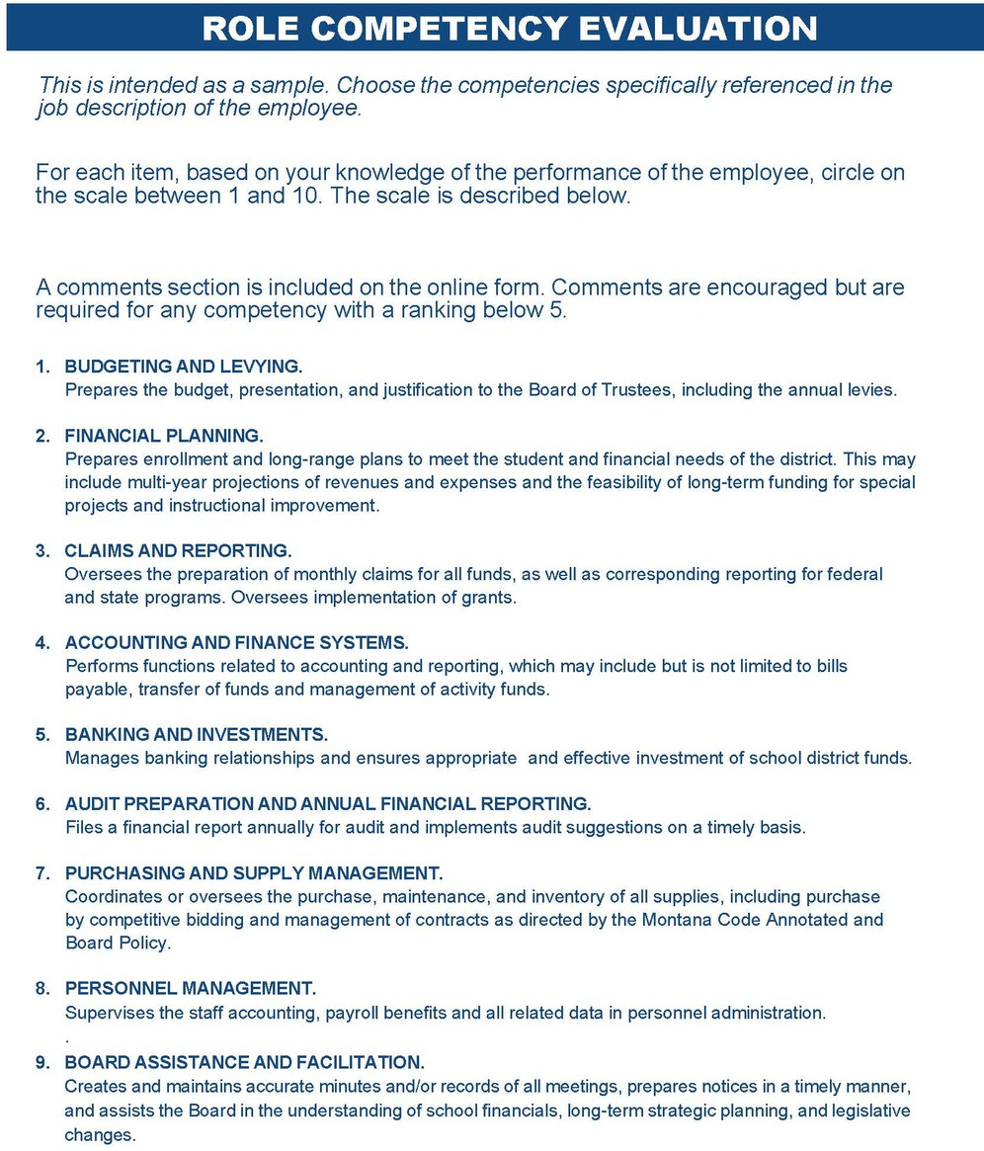

**10. COLLECTIVE BARGAINING.**

Prepares pertinent fiscal data for negotiations, including data related to benefit programs.

**11**. **RECORDS MANAGEMENT.**

Oversees procedures and maintenance of district property, finance records and the annual financial audit.

1. **PROGRAM MANAGEMENT.**

Oversees the operation of the total school business services program including day-to-day district finance and business operations, recruitment, and evaluation of staff.

1. **INSURANCE AND RISK MANAGEMENT.**

Represents the district's interests in all insurance and risk management programs.

1. **TRANSPORTATION SERVICES.**

Administers or oversees the district transportation program and prepares and administers the budget.

1. **FACILITY OPERATIONS.**

Administers a program of plant operation and maintenance, security and property protection and community use of school facilities.

1. **PLANNING AND CONSTRUCTION.**

Participates in decision-making process and selection of professional services. Works with architects and contractors to ensure desired project results in construction and remodeling of facilities and understands and fulfills title legal responsibilities of the district.

1. **FOOD SERVICE.**

Oversees all operations and contracts. Applies State and Federal guidelines for free/reduced meal subsidies. Takes part with regulatory agencies in the planning and reporting of food service programs.

1. **HEALTH AND SAFETY.**

Develops and implements a process for assessing potential safety hazards. Assists in the preparation of a district disaster preparedn1ess and recovery plan.

1. **COMMUNITY RELATIONS.**

Prepares enrollment projections and financial information for meetings and elections. Effectively communicates financial and operational issues to the public. Represents the mission and goals of the district to the community.

1. **GENERAL ADMINISTRATION.**

Acts as advisor to the superintendent concerning financial affairs and matters of general importance to the educational program. Participates in decision-making and policy development.

1. **PROFESSIONAL DEVELOPMENT.**

Sets goals and participates in activities to maintain knowledge and skills and stay abreast of school finance related issues.

#### Sample two

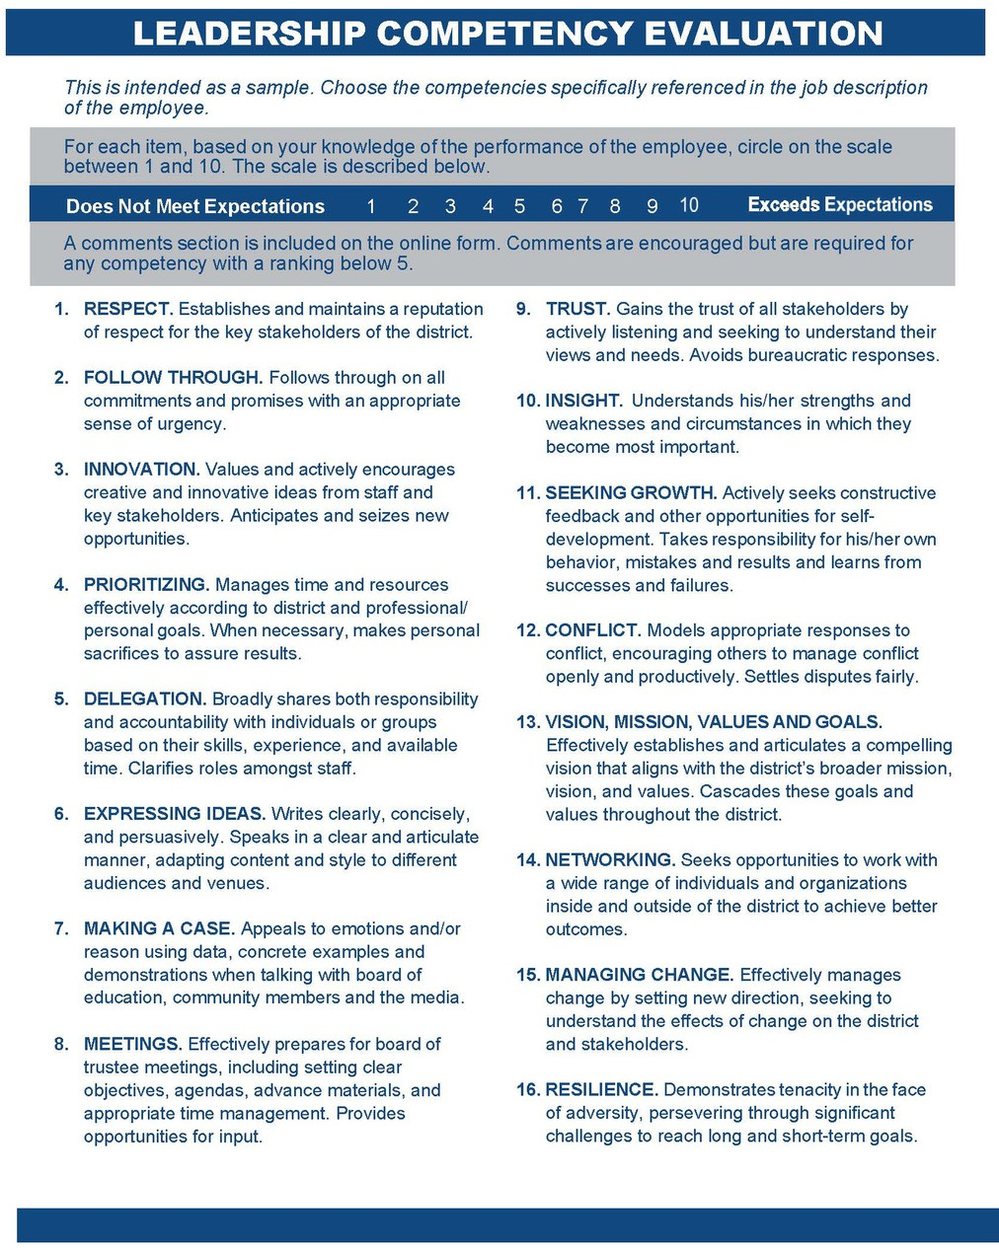

***Sample three***

MODEL- District Clerk/School Business Manager Evaluation

School Year Employee Name

Years completed.

PURPOSE:

This evaluation is conducted to provide the District Clerk/School Business Manager with the School Board's assessment of his/her strengths and weaknesses relative to the performance of the District Clerk/Business Manager of School District # . It is the intent that this instrument will serve to provide the District Clerk/Business Manager with reinforcement of effective performance and to be used as a guide for change and/or improvement. Comments should include goals for future projects and performance.

KEY TO THE RATING SCALE:

Chose a rating based on applicable factors, such that the applicable factors, in general, most closely describe the District Clerk/School Business Manager's performance based on your observation.

1. Not applicable, no knowledge, or unable to evaluate.
2. Performance does not meet job requirements, performance improvement plan required.
3. Performance is below average.
4. Performance is satisfactory.
5. Performance is above average or exceeds job requirements.

* An explanatory comment should be provided when either option "1" or "2" is selected. Space has been provided accordingly.

Board and Administration Relations

Supports, interprets, and enforces school district policy. Assumes leadership in implementation of the district’s goals.

Not Known 0 1 2 3 4 Exceeds Standards

Publishes notices, attends, and/or participates in all Board meetings, maintaining an accurate record of actions and participants, and provides timely publication of the minutes.

Not Known 0 1 2 3 4 Exceeds Standards

Keeps the Board of Trustees informed on issues, needs, and operations of the school system.

Not Known 0 1 2 3 4 Exceeds Standards

Offers professional advice to the Board of Trustees on items requiring Board action, making recommendations based on thorough analysis. Uses legal counsel when appropriate.

Not Known 0 1 2 3 4 Exceeds Standards

Collects information and assists the school administrator and the school board with contract negotiations.

Not Known 0 1 2 3 4 Exceeds Standards

Bases any position upon principle and maintains that position without regard for its popularity until an official position has been reached. Thereafter, the decision of the Board is supported, even if the decision may not conform to personal beliefs.

Not Known 0 1 2 3 4 Exceeds Standard

Assumes additional administrative responsibilities willingly.

Not Known 0 1 2 3 4 Exceeds Standards

Is willing to make decisions when appropriate, adapts to unusual situations effectively and creatively, and uses logical and reasonable thought processes.

Not Known 0 1 2 3 4 Exceeds Standards

Continues professional development through reading, coursework, conference attendance, and interaction with Business Managers/District Clerks from other Districts. Develops, uses, and evaluates effective approaches to improve job performance.

Not Known 0 1 2 3 4 Exceeds Standards

Represents the school district professionally in local, regional, state, and national affiliation and participation.

Not Known 0 1 2 3 4 Exceeds Standards

Comments:

Position Specific Responsibilities

Accurate in collection of monies, determines that funds are spent wisely, and that adequate control and accounting procedures are maintained. Operates within State and District guidelines and procedures governing expenditures of funds for goods and services.

Not Known 0 1 2 3 4 Exceeds Standards

Reconciles cash accounts and reports to the Board monthly. Evaluates financial status and makes recommendations for adequate funding. Provides realistic estimates of financial requirements. Plans and reports on present and future needs. Demonstrates an ability to effect desirable budgetary changes.

Not Known 0 1 2 3 4 Exceeds Standards

Supervises the payroll function for the district including employee benefits, state and federal tax deposits, workers’ compensation insurance and other related activities.

Not Known 0 1 2 3 4 Exceeds Standards

Supervises human resource requirements for personnel including collective bargaining agreement adherence, state, and federal labor laws, and does so with an assurance of accuracy and confidentiality.

Not Known 0 1 2 3 4 Exceeds Standards

Collaborates with school administrator to meet all Human Resource needs based on federal and state guidelines.

Not Known 0 1 2 3 4 Exceeds Standards

Collaborates with school administrator to actualize school vision and operationalize yearly initiatives.

Not Known 0 1 2 3 4 Exceeds Standards

Reviews, codes, and organizes payables so they are ready for approval at the monthly Board meeting. Monitors receivables and manages collection practices, when required.

Not Known 0 1 2 3 4 Exceeds Standards

Supervises vendor relations including maintenance contracts and bid requests.

Not Known 0 1 2 3 4 Exceeds Standards

Encourages personnel to care for school property and safeguards physical facilities. Monitors and manages major facility changes or improvements as needed.

Not Known 0 1 2 3 4 Exceeds Standards

Administers and conducts all school district elections as prescribed by law.

Not Known 0 1 2 3 4 Exceeds Standard

Completes an accurate Financial Summary to the Office of Public Instruction annually and participates openly and actively with all annual audit requirements.

Not Known 0 1 2 3 4 Exceeds Standards Comments:

Staff and Community Responsibilities

Models positive and professional attitude.

Not Known 0 1 2 3 4 Exceeds Standards

Creates conditions in the workplace that allows others to hold professional pride and enthusiasm; encourages a collaborative spirit.

Not Known 0 1 2 3 4 Exceeds Standards

Adheres to school district guidelines concerning the use of facilities and equipment for community or school related activities.

Not Known 0 1 2 3 4 Exceeds Standards

Responds respectfully to the community and staff when problems are identified. Maintains composure when faced with unexpected challenges.

Not Known 0 1 2 3 4 Exceeds Standards

Celebrates staff members whose performance has been outstanding and acknowledges growth and effort.

Not Known 0 1 2 3 4 Exceeds Standards

Consults privately with those staff members whose performance is not acceptable. Not Known 0 1 2 3 4 Exceeds Standards

Understands and respects students as individuals.

Not Known 0 1 2 3 4 Exceeds Standards

Comments:

Final Comments and Recommendations:

Evaluator Name: Evaluator Signature: Employee Comments:

Employee Signature:

Date: