MONTANA ASSOCIATION OF SCHOOL BUSINESS OFFICIALS
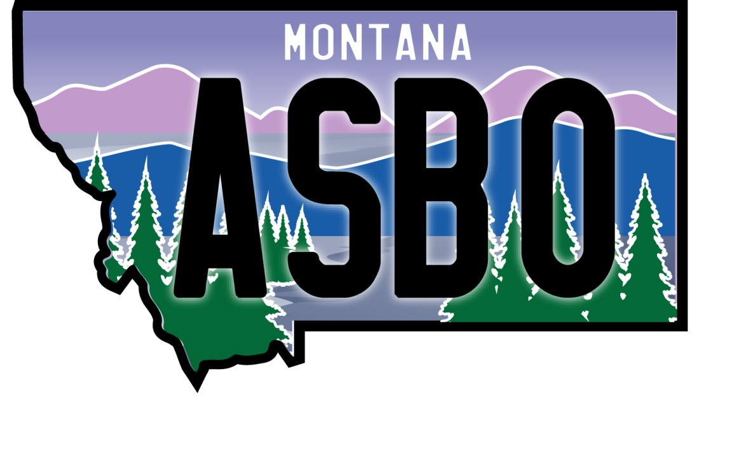
ELECTIONS WORKSHOP AGENDA - 2020
December 1 - Virtual workshop via ZOOM

8:00 - 8:30 Welcome and Introductions

8:30 - 9:45 Election Overview

9:45 - 10:15 Break

10:15 - 11:30 Election Process
11:30 - 12:30 Lunch
12:30 - 1:45 Mail Ballot vs. Poll Elections and Election Security
1:45 - 2:15 Break
2:15 - 3:30 Election Day and Beyond

Thank you to our workshop sponsor:

Shawn Bubb, Director of Insurance Services
406-457-4500
sbubb@mtsba.org
http://www.msgia.org/home

