BILLINGS SCHOOL DISTRICT #2
NOTICE OF INTENT TO INCREASE NONVOTED LEVIES
March 20, 2017

The Billings School District is committed to financial transparency. Senate Bill 307 (SB307), which is working its way through the legislature, requires the District to provide notice of its intent to increase non-voted levies in the ensuing fiscal year. However, understanding the District’s budgets requires considering all levy-supported funds. As a result, the proposed notice contains projections for all of the District’s levy-supported funds:

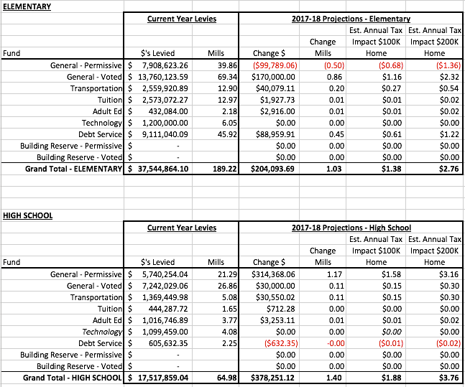

The District intends to use the permissive Building Reserve levies listed above for technology improvements and improving energy efficiency.

These estimates are the District’s best estimates at the current time. They are based on the current year’s taxable value, as required by the proposed law in SB307. If the District’s taxable value increases as expected, the mill and taxpayer cost increases will be less than presented here. These estimates are preliminary and changes are expected before the final budgets are set in August. Please contact the District Business Office at (406) 281-5017 or arnoldms@billingsschools.org if you have questions or need additional information.

