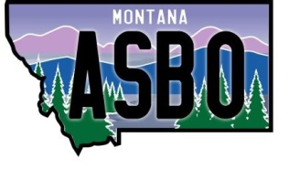

MASBO Region 4 Spring Workshop
April 1, 2019
Comfort Inn Butte

8:00-8:30 Registration
8:30-8:45 MASBO Regional Business Meeting
8:45-9:30 Legislative Update – Denise Williams
9:30-10:30 Grant Management – Dennis Clague
10:30-10:45 Break
10:45-11:45 GEMS Tutorial
11:45-12:45 Lunch
12:45-1:45 Board of Investments – Dan Villa
1:45-2:45 Best Practices – Dan Moody
2:45-3:45 Business Manager/Clerk Employment Issues – Betsy Griffing

