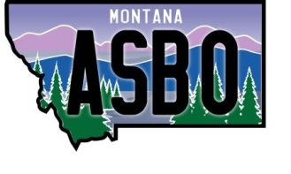
MASBO- Region 5 Spring Workshop
March 29, 2019 - 8:00 am to 4:00 pm
Red Lion Hotel
5550 Midland Road, Billings, MT

8:00 - 8:30 Registration

8:30 - 8:45 MASBO Regional Business Meeting
*Welcome & Introductions

8:45 – 9:30 Legislative Update – Denise Williams

9:30 - 10:15 TRS Termination Calculator and any other Tips and Tricks – Darla Fitzpatrick

10:15 - 10:30 Break

10:30 – 11:15 PERS – Tips and Tricks – Jenny Weigand

11:15 – 12:15 OPI – Kara Sperle and Dan Moody

12:15 – 1:00 Lunch – provided by MASBO

1:00 - 1:30 Workers Compensation/Unemployment and Independent Contractors – Andy Salaba

1:30 – 3:00 Google Training – Mark Branger – Bring your laptop

3:00 – 3:15 Break

3:15 – 3:45 Yoga for the Office – Cheryl Blacquire

3:45 – 4:00 Wrap Up

